ARYAMAN MISHRA

19BCE1027

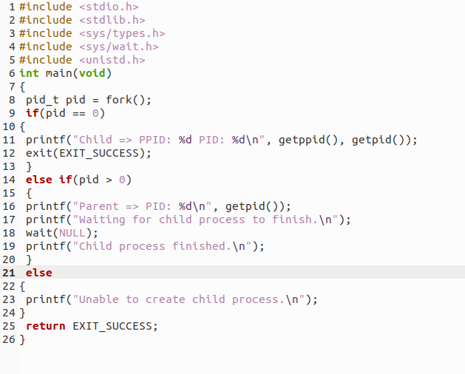

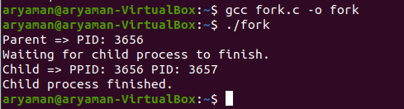

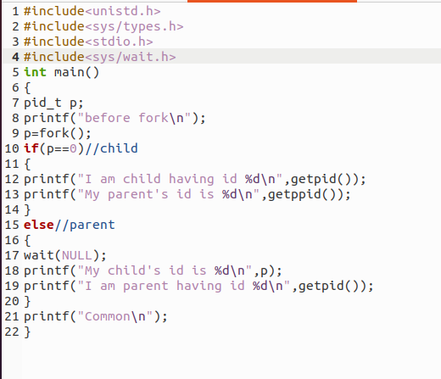

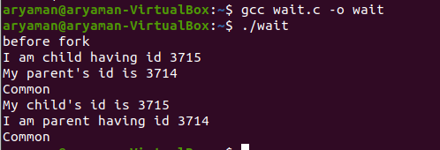

#include<stdio.h>

int main()

{

for(int i=0;i<5;i++) // loop will run n times (n=5)

{

if(fork() == 0)

{

printf("[son] pid %d from [parent] pid %d\n",getpid(),getppid());

exit(0);

}

}

for(int i=0;i<5;i++) // loop will run n times (n=5)

wait(NULL);

}

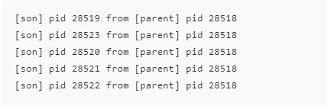

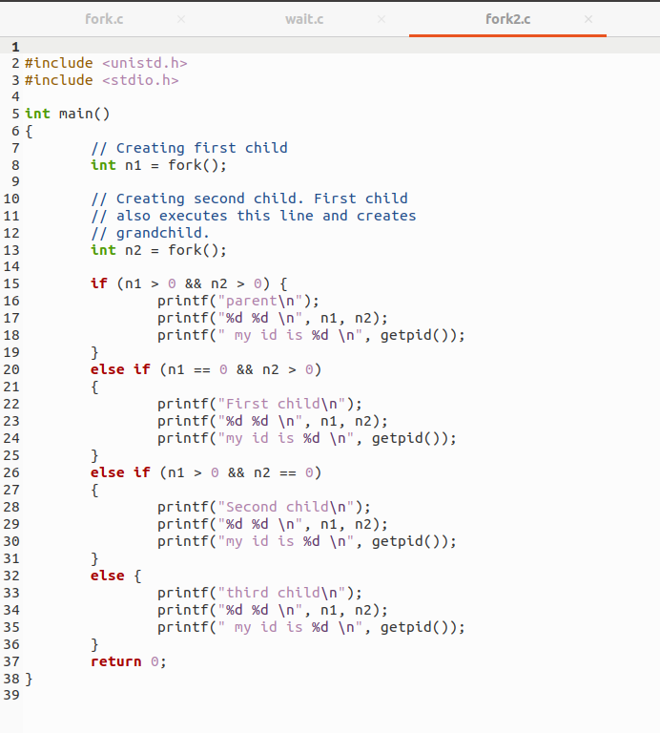

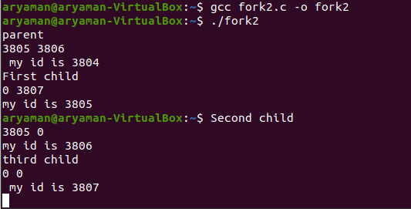

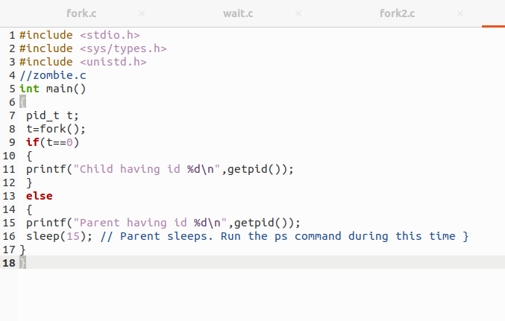

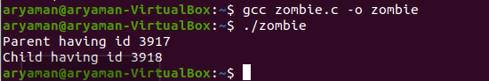

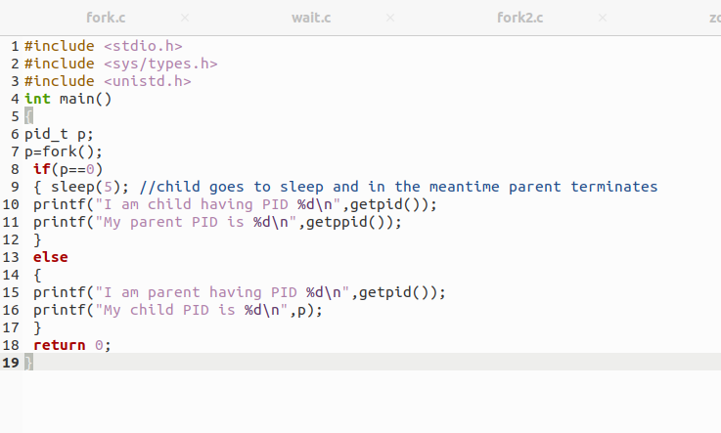

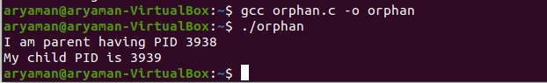



**A simple C program to demonstrate use of pthread basic functions**

#include <stdio.h>

#include <stdlib.h>

#include <unistd.h> //Header file for sleep(). man 3 sleep for details.

#include <pthread.h>

// A normal C function that is executed as a thread

// when its name is specified in pthread_create()

void *myThreadFun(void *vargp)

{

sleep(1);

printf("Printing Aryaman from Thread \n");

return NULL;

}

int main()

{

pthread_t thread_id;

printf("Before Thread\n");

pthread_create(&thread_id, NULL, myThreadFun, NULL);

pthread_join(thread_id, NULL);

printf("After Thread\n");

exit(0);

}

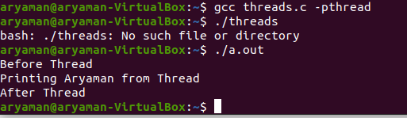

**A C program to show multiple threads with global and static variables**

